Real Estate Management System

For Subject: System analysis and design-2

|  |
| --- |
| Students |
| Ahmed Mohamed Eltras |
| Ola Elfiky |
| Alaa Ezzat |
| Abdelfatah Ahmed |

Object-Diagram

|  |  |  |
| --- | --- | --- |
| Entity | Control | Boundary |
| Customer | Booking | Booking Application Form |
| Search | SearchField |
| Seller | Start New  Application | New Application |
| Alter | Alter Product |
| Admin | Show Requests | Show Button |
| Search | SearchField |
| Alter | Alter Product |

|  |  |
| --- | --- |
| The Seller | logs into the site and submits his request to display the properties which he wants to sell |
| The Customer | searches for the property he to buy on the site. |
| The admin | 1- act as an intermediary between seller and customer  2- check entered data  3- providing real estate management services |

|  |  |
| --- | --- |
| Search Button | Button used customer to search about property |
| Delete Button | Button used by seller to delete data from site |
| Update Button | Button used by to update data of property |
| Add Button | Button used by seller to add information about property or add new property |
| Signup Button | Button used by seller to sign-in into site to view properties he wants to sell |
| Check Button | Button used by admin to check the entered data and verifies accuracy |
| Show Button | Button used by admin to display the requests entered by sellers |

Sequence Diagrams

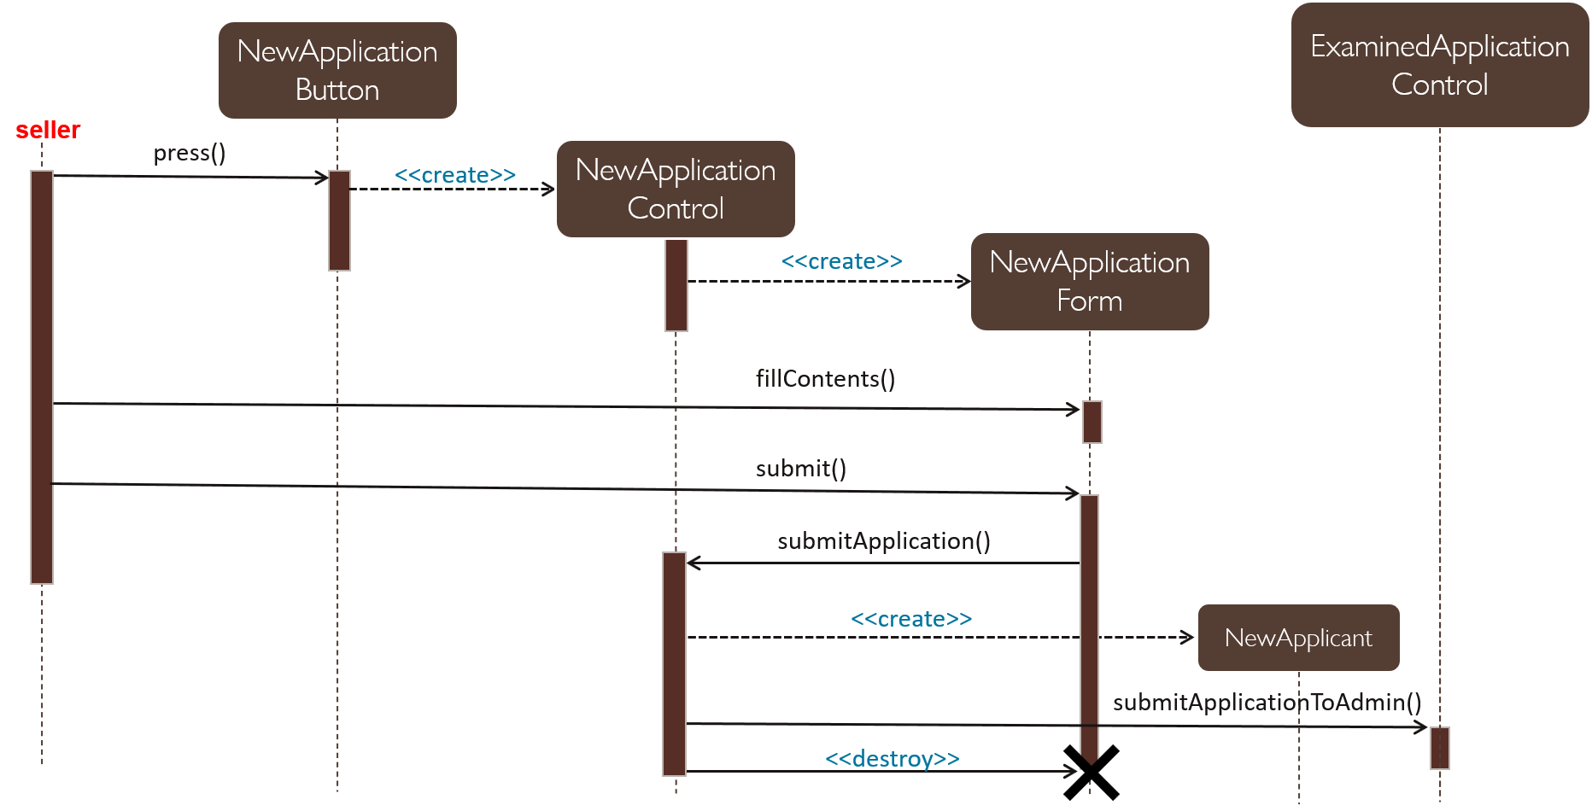Make a new Application

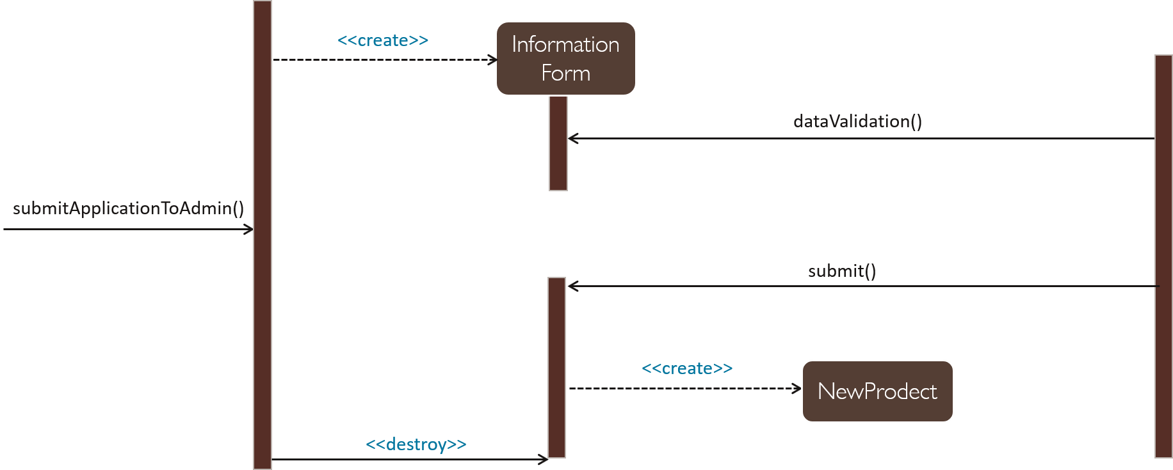

Admin

Delete and Update

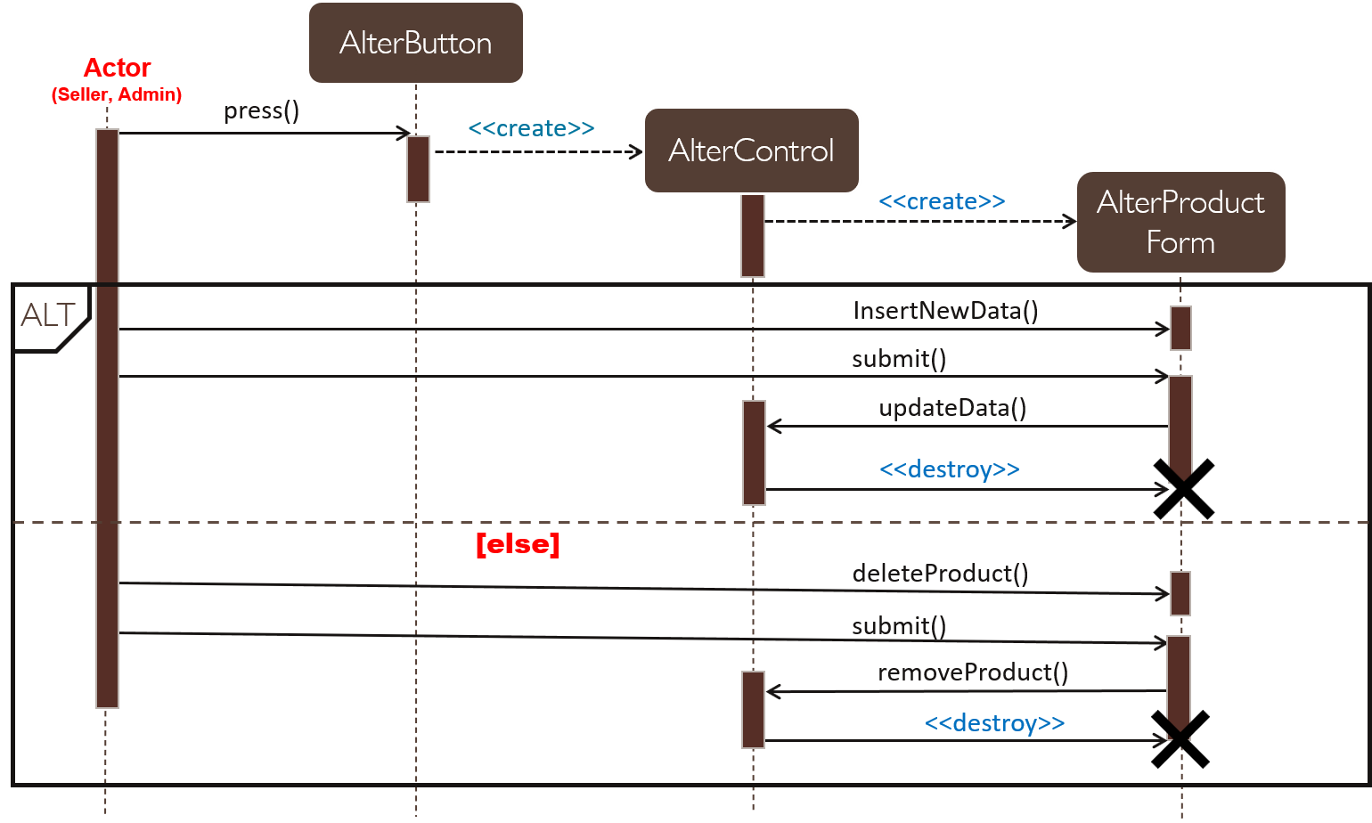

Booking Sequence Diagram

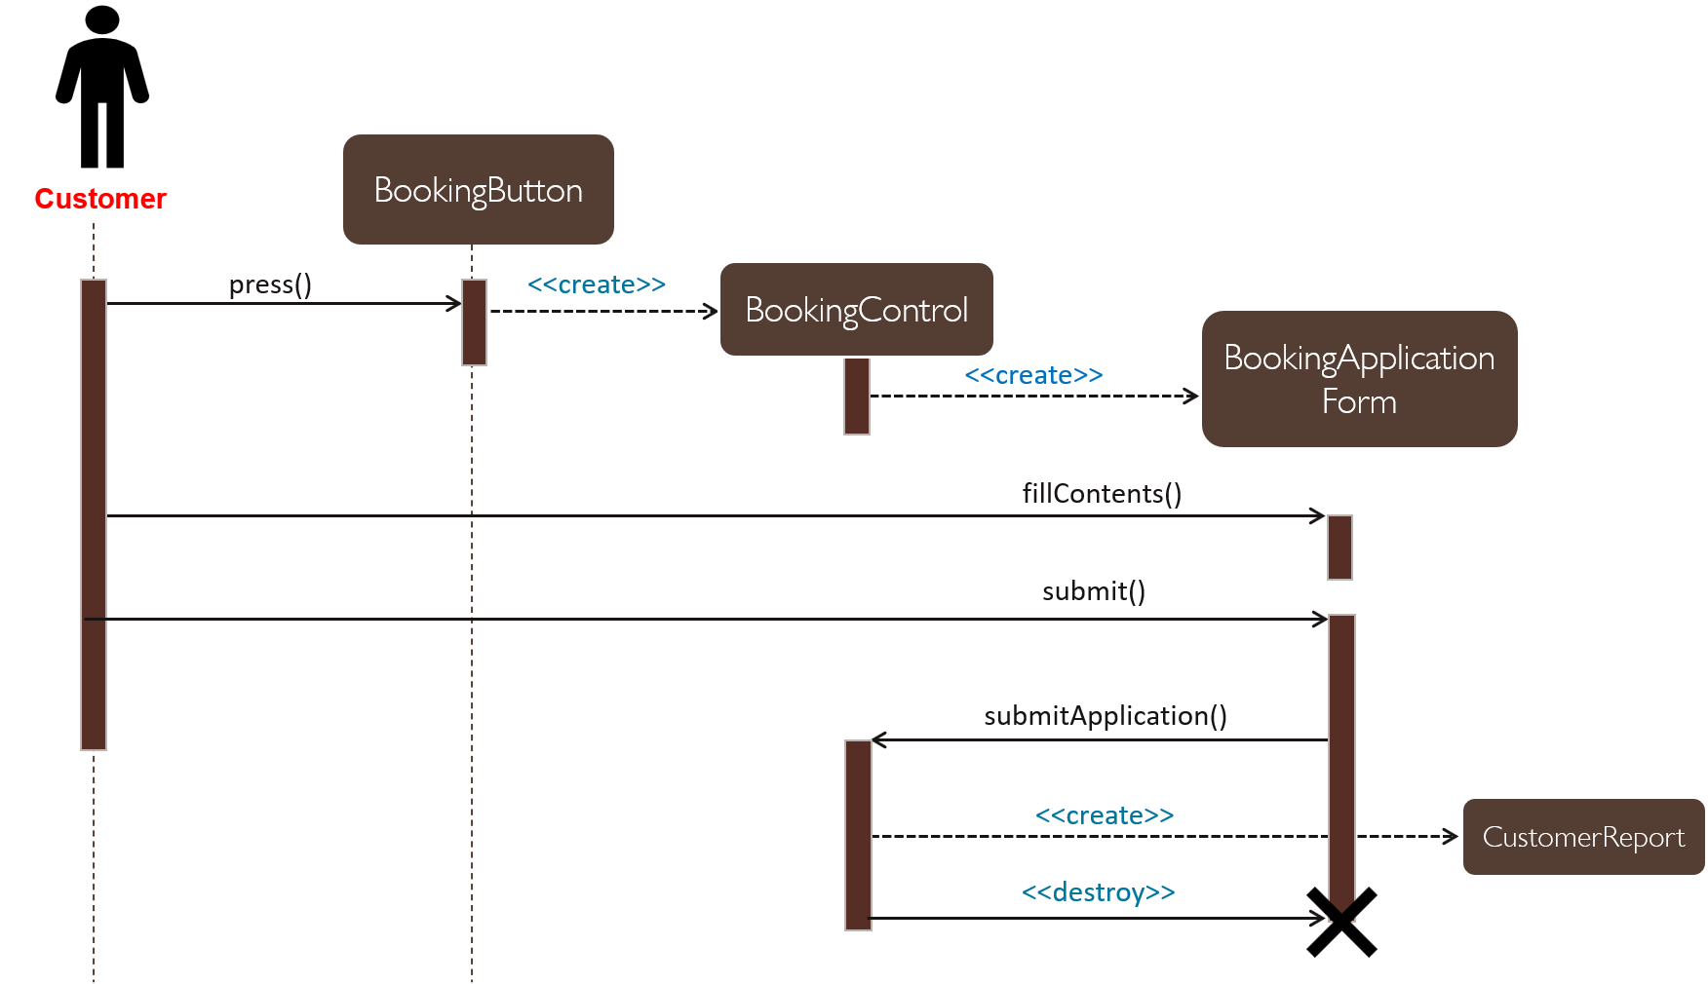

Class Responsibilities Collaborators (CRC)

|  |  |
| --- | --- |
| Seller | |
| Responsibilities | Collaborators |
| 1. The seller will enter the data of the property through the property registration form and its data 2. He will modify the previous data that was entered in the property | 1. New Application 2. Alter Product |

|  |  |
| --- | --- |
| Customer | |
| Responsibilities | Collaborators |
| 1. The customer will reserve the building or the real estate asset 2. The customer will search for the building or real estate asset by region, price and area. | 1. Booking Application Form 2. SearchField |

|  |  |
| --- | --- |
| Admin | |
| Responsibilities | Collaborators |
| 1. Amendment to the system and real estate and property data 2. Acceptance and rejection of the data of the property entered by the seller | 1. Show Requests 2. Modify Product |

Attribute

|  |
| --- |
| New Application |
| Address: string  Value: number  Owner: string  Area: number  Photo: image |

|  |
| --- |
| Register |
| Email: string  Name: string  Phone: number  Address: string  Pass: number |

|  |
| --- |
| Login |
| Email: String  Pass: number |

|  |
| --- |
| Search |
| Address: String  Value: number  Rate: string |

|  |
| --- |
| Booking Application |
| Name: string  Phone: Number  Time: Number  Date: Number |